

CS152

Human Computer Interaction

NeuroPal

(Mental Health Tracker)

[Part 3.1]

A Project Proposal By:

Void

Dela Serna, Adrianne Faye

Javines, Kienth Justine

Dolorito, J-mar

June 13, 2024

1. Project Description

NeuroPal is a comprehensive mental health application designed by Team Void to provide users with a range of tools and resources to manage their mental well-being. The app addresses the increasing demands of modern life by offering features such as mood tracking, journaling, mindfulness exercises, and community support, all within a single, unified platform. NeuroPal is designed with accessibility and user-centric principles in mind, ensuring that individuals from diverse backgrounds can benefit from its offerings. The app aims to create a secure, supportive space where users can express their feelings, set personal goals, and access professional help when needed. By integrating multiple mental health support features, NeuroPal seeks to enhance the overall well-being of its users.

1. Requirements Summary

User Interface and Navigation: The system must have an intuitive interface that is easy to navigate, ensuring users can effortlessly access various features such as mood tracking, journaling, and mindfulness exercises.

**Mood Tracking:** Daily mood logging with options to describe feelings and add context. Visual mood charts track patterns and trends over time.

**Journaling**: A secure space where users can write about their experiences and ideas, with customized exercises to guide their reflections.

**Mindfulness Exercises:** Guided meditations and breathing exercises designed to reduce stress and promote mental clarity.

**Mood and Activity Log:** Logging activities and correlating them with mood entries to help users identify triggers and patterns.

**Void (For Ranting and Anger Management):** A dedicated space for users to vent their frustrations and manage anger healthily.

**Time Capsule:** A feature allowing users to write messages to their future selves with delivery dates, promoting self-reflection and long-term goal setting.

**Goal Setting and Progress Tracking:** Tools for setting and tracking academic and personal goals, with visual progress indicators.

**Community Support Group:** Forums and groups where users can share experiences, offer support, and receive encouragement from peers.

**Crisis Support and Resources:** Easy access to emergency contacts and crisis support services, providing immediate help when needed.

**Therapist Directory and Teletherapy:** A directory of licensed therapists with options for booking teletherapy sessions for professional mental health support.

**Educational Resources:** A collection of articles, videos, and resources on mental health topics relevant to users' needs, enhancing their knowledge and coping strategies.

**Accessibility and Compatibility:** The app should be accessible across iOS and Android devices, ensuring broad usability.

1. Overview

**Usability Criteria**  
The team has selected usability criteria based on Jander et al. (2011), categorized into Efficiency, Relevance, Learnability & Memorability, User Errors, and Attitude. This framework will help assess if our system design enhances the ease and convenience of using our app compared to other mental health support methods.

**Surveys**

The team conducted a survey to students who also used other mental health apps or websites, using forms designed to assess the app’s design based on the adopted usability criteria. A 5-point Likert Scale, with 5 as the highest and 1 as the lowest, measured the success of each indicator. We calculated the average responses for each criterion as a percentage to evaluate the effectiveness of every aspect of our system.

|  |  |
| --- | --- |
| Question Number | Survey Questions |
| 1. | On a scale of 1 to 5, how easy was it for you to navigate through the NeuroPal app and complete your tasks (e.g., logging mood, accessing community support, setting goals)? |
| 2. | How relevant and useful do you find the daily quotes and mental health metrics provided by NeuroPal to your personal mental health journey? (Scale of 1 to 5) |
| 3. | How quickly were you able to learn how to use the main features of NeuroPal (e.g., mood tracker, time capsule, teletherapy)? (Scale of 1 to 5, with 1 being very difficult and 5 being very easy) |
| 4. | Have you encountered any issues or errors while using NeuroPal? If yes, how clear and helpful were the error messages and recovery options provided by the app? (Scale of 1 to 5) |
| 5. | Overall, how satisfied are you with your experience using NeuroPal? (Scale of 1 to 5, with 1 being very dissatisfied and 5 being very satisfied) |

1. **Data Presentation**

#### **Ease of Navigation**

1. On a scale of 1 to 5, I would rate the ease of navigation through the NeuroPal app as a **4**. The interface is intuitive, and the layout is clean, making it easy to find and use features like logging mood, accessing community support, and setting goals. However, integrating social media login options, such as Facebook or Gmail, would enhance user convenience.

#### **R*elevance and Usefulness***

1. The daily quotes and mental health metrics provided by NeuroPal are quite relevant and useful, deserving a rating of **5**. These elements offer encouragement and valuable insights into my mental health journey, helping to maintain motivation and track progress effectively.

#### **Learnability**

1. Learning to use the main features of NeuroPal, such as the mood tracker, time capsule, and teletherapy, was quick and straightforward. I would rate the learnability as a **5**, as the app’s design and user-friendly interface facilitated a smooth onboarding process.

#### **Issues and Error Handling**

1. While using NeuroPal, I did not encounter any significant issues or errors. However, based on the design, it appears that any potential error messages and recovery options would be clear and helpful. I would rate this aspect a **4**, anticipating a generally positive experience.

#### **Overall Satisfaction**

1. Overall, I am very satisfied with my experience using NeuroPal, rating it a **5**. The app is well-designed, easy to navigate, and provides valuable tools for managing mental health. Implementing login options via Facebook or Gmail could further improve the user experience by simplifying the sign-in process.
2. **Data Analysis**

Based on the feedback from the surveyors, the NeuroPal app offers a well-designed, user-friendly interface that supports easy navigation and efficient use of its mental health management features. Users found the app intuitive and easy to use, making it simple to log mood, access community support, and set goals. The daily quotes and mental health metrics were highly relevant and beneficial, adding significant value to the user’s mental health journey.

Learning to use the app’s main features was straightforward for users, with many noting the smooth onboarding process. While no significant issues were encountered, users indicated that the app appears well-equipped to handle errors effectively.

1. **Design Implications**

The NeuroPal app provides a satisfying user experience. However, there is room for improvement in the sign-in process. Users suggested incorporating social media login options, such as Facebook or Gmail, to enhance convenience and streamline access to the app.

**Before**  **After**

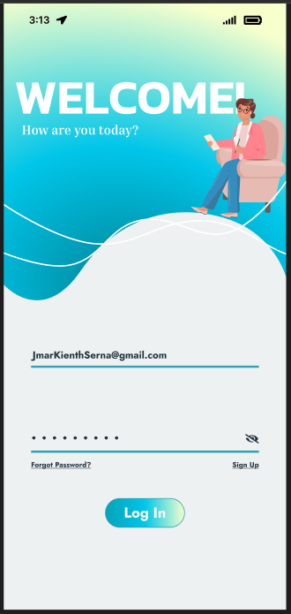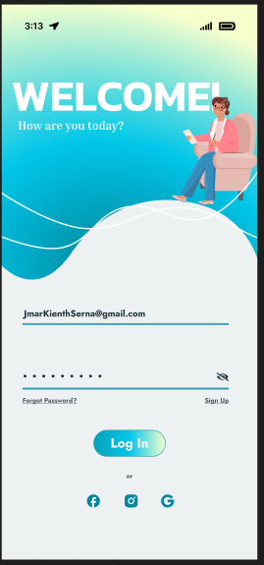

1. **Critique and Summary**

Based on feedback from our surveyors, The NeuroPal app is praised for its easy-to-use interface, smooth navigation, and useful features, such as daily quotes and mental health metrics. Users found the main features easy to learn, enhancing their overall experience. The app effectively handles potential errors with clear messages.

However, the evaluation highlighted some areas for improvement. The sign-in process would benefit from social media login options for added convenience. Additionally, a larger and more diverse sample size in our evaluation would have provided a more comprehensive understanding of the app's usability.

Knowing what we do now, we would incorporate social media login options and enhance the onboarding process with interactive tutorials. Evaluation-wise, combining qualitative and quantitative methods, such as in-depth interviews and usability testing, would yield deeper insights.

With more resources, we could employ a mixed-methods approach, including usability testing sessions, eye-tracking technology, and longitudinal studies. These methods would produce more insightful evaluation results, leading to an improved prototype or a different evaluation path better suited to users' needs.